EXPERIMENTATION IN ORGANIC CHEMISTRY:

3rd Practice: Addition Elimination
- Main Features of the practice:
  - Main objective of the practice:
    - Perform a dehydration reaction (elimination) and a bromination reaction (addition). Both very typical and basic reactions in a laboratory
  - Mechanism of the reaction:
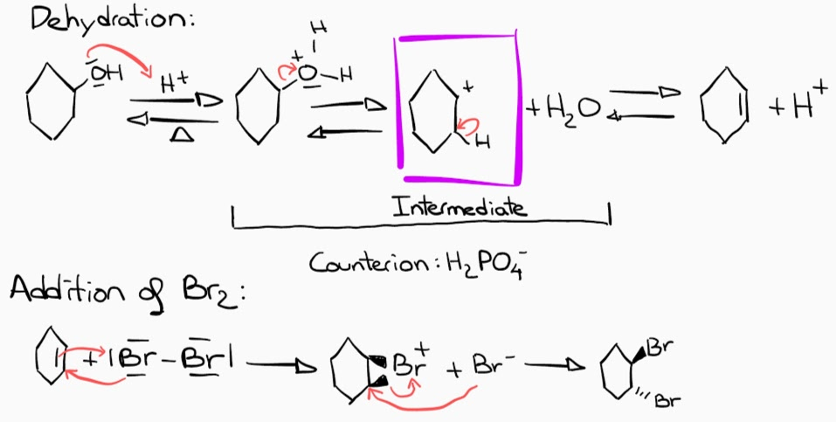
We can observe that H⁺ is catalytic because it is consumed in the first step of the dehydration but it another one is released in the last step. Moreover, as we can see, all the reactions in the elimination are equilibriums so all the process will be an equilibrium. Consequently, we will have to find a way to push the reaction rightwards, in our case, we will get rid eliminate the product from the medium of reaction.
  - Dangerous reagents, preventive measures; H and P phrases
Dangerous Reagents | Preventive Measures; H and P phrases
Cyclohexanol | H302: Harmful if swallowed.  H312: Harmful in contact with skin.  H315: Causes skin irritation.  H319: Causes serious eye irritation.  H332: Harmful if inhaled.  H335: May cause respiratory irritation.  H412: Harmful to aquatic life with long lasting effects.
Phosphoric acid | H314: Causes severe skin burns and eye damage.  H318: Causes serious eye damage.
Bromine | H314: Causes severe skin burns and eye damage.  H318: Causes serious eye damage.  H330: Fatal if inhaled.  H400: Very toxic to aquatic life.
Sodium Sulphate Anhydrous | H412: Harmful to aquatic life with long lasting effects.  P273: Avoid release to the environment.  P501: Dispose of contents/container to an approved waste disposal plaint.

  - Experimental Procedure and Observations:
Elimination Reaction and its purification:
- Pour 20mL Cyclohexanol, 6mL H₃PO₄ and a magnetic stirrer into a 50mL round bottomed flask
- Connect the distillation system and add a 50mL Erlenmeyer at the end to collect the liquid.
- Stir but heat slowly until the product starts distilling.
- Maintain the temperature under 100 °C.
- Keep heating until 5-6 mL of liquid in the round bottomed flask or the temperature reaches 100 °C.
- Move the distilled product to an extraction funnel. Add a solution of concentrated NaCl is added to create the aqueous phase and permit a proper differentiation of their densities.
- Mix vigorously, depressurize and repeat this process 3 times. Let the funnel quiet to let the phases divide correctly.
- Extract the top phase (organic phase) and get rid of the bottom one (aqueous phase).
- Add Na₂SO₄ in order to completely eliminate the rests of water in the organic phase. Then filtrate the salt and recover the cyclohexene.
- Redo a distillation and all the previous steps to get a purer product.
Addition Reaction and its purification:
- Get 100 mg of the previously obtained cyclohexene and dissolve it in 2 mL of CH₂Cl₂ in a wide neck round bottomed flask.
- Dropwise add 0,5M Br₂ in CH₂Cl₂ while stirring the content in the flask. The red colour of Br₂ will disappear but eventually it will not disappear no more. At this point stop adding Br₂.
- Using the rotavapor evaporate the solvent and weigh the final product.

- Results:

Molecular formula | MW (g/mol) | Density (g/cm³) | State | Colour
C₆H₁₁OH | 84,16 | 0,962 | Liquid | Colourless
C₆H₁₀ | 82,143 | 0,811 | Liquid | Colourless
C₆H₁₀Br₂ | 241,95 | 1,784 | Liquid | Colourless/light yellow

Calculations of n:
$$C_{6}H_{11}OH →20 mL×\frac{0,962 g}{1 mL}=19,24 g$$
$$n_{C_{6}H_{11}OH}=19,24 g ×\frac{1 mol}{84,16 g}=0,2286 mol=n_{C_{6}H_{11}OH}=n_{C_{6}H_{10}}$$
$$n_{C_{6}H_{10}{Br}_{2}}=0,1 g ×\frac{1 mol}{82,143 g}=1,22x10^{-3} mol C_{6}H_{10}{Br}_{2}$$
Theoretical weight or volume of final product:
$$m_{C_{6}H_{10}}=0,2286 mol×\frac{82,143 g}{1 mol}=18,778 g C_{6}H_{10}$$
$$m_{C_{6}H_{10}{Br}_{2}}=1,22x10^{-3} mol×\frac{241,95 g}{1 mol}=0,294 g C_{6}H_{10}{Br}_{2}$$
Theoretical Melting or Boiling point (°C):
C₆H₁₀ → T_{boiling} = 83°C
C₆H₁₀Br₂ → T_{boiling} = 145°C
  - Yield. Analysis of the results:
- Yield of the elimination reaction
$$Yield=\frac{10,00}{18,778}×100=53,254 \%$$
- Yield of the addition reaction
$$Yield=\frac{0,200}{0,294}×100=68,03 \%$$

  - Spectroscopic Data:
H-NMR of cyclohexene:
We can observe that the molecule is totally symmetric, so, we will observe half of the signals that we would expect, to be precise, 3 signals.
- 5.67 ppm: This signal belongs to the H of the CH of the double bond. Due to its high chemical shift and integration, we can conclude that it must be the H nearest to the double bond.
- 1.99-1.49: This is the H in α position about the double bond. Because it is in between the other two signals, we can guess that the H will be in the core of the structure. Moreover, the chemical shift value corresponds to this hypothesis.
- 1.49: This is the furthest H from the double bond, so it makes sense that it is the signal with the smallest chemical shift.
C-NMR of cyclohexene:
In this case too, as the molecule is symmetric, we will only observe 3 signals:
- 127.3 ppm: This signal belongs to the double bond C because it has the highest chemical shift due to the effect of the double bond.
- 25.3 ppm: This signal is the C next to the double bond. It is a bit more decoupled than the next signal and it is in the middle of the molecule.
- 22.8 ppm: This signal is the less decoupled so it must then be the furthest C from the double bond.
IR spectra of cyclohexene:
The signal at approximately 3000 µm means that the molecule is unsaturated. There is a peak at around 1680 µm which corresponds to the C=C bond.

H-NMR of 1,2-dibromocyclohexane:
We can observe that the molecule is not totally symmetric due to the trans position of the bromines and the chair conformation of cyclohexane. Consequently, hydrogens in axial position will receive less effect from the bromide than the equatorial ones. However, the rest of the molecule is symmetric so the signals will be less than expected, only 4.
We can see 4 different signals which correspond to the previously predicted quantity of H:
- 4.54 - 4.30: Its integration lets us know that it is 1H and because it is the signal with the highest chemical shift, we can guess it is the H next to Br because it is attached to the most electron absorbing group.
- 2.41ppm: It must be the H in α and equatorial position because it has the second biggest chemical shift.
- 1.93-1.62 ppm: These signals are of the H_{α} (axial) and H_{β} (equatorial). The effect of the bromide in these H is so similar that they group up.
- 1.36 ppm: This signal belongs to H_{β} (axial) because it is the signal with the less chemical shift.

C-NMR of 1,2-dibromocyclohexane:
We can observe that the molecule is totally symmetric and consequently there won’t be 6 signals of C-NMR, instead there will be 3 signals.
The signal at around 78 ppm is the signal of the solvant, we don’t have to pay attention to it.
- 55.2 ppm: It will be the signal for C attached to Br because it is the signal with the highest chemical shift.
- 31.9 ppm: The signal will be the one of the C in the β position with Br. It is a bit lower than the first because there is a bigger distance between the bromide and this signal.
- 22.4 ppm: The signal is caused by the C in γ position with Br. It has the lowest chemical shift because it is the furthest C from the bromide.

IR spectra of trans-1,2-Dibromocyclohexane:
We can observe a peak at around 850 µm which represents the bromides. Apart from that, there aren’t any other remarkable signals.
  - Conclusions:
Even though we didn’t have the chance to access the lab and proceed with the practices ourselves, we have been able to see some of the concepts we have learnt in Kimika Organikoa I put into practice which can be very beneficial for our comprehension in the matter.

